**Project I4 Summer Learning Exchange Curriculum**

**PROTOCOL: APPRECIATIVE OR CONSTRUCTIVIST LISTENING**

**Other protocols available on iel.org/protocols**

**Appreciative or Constructivist Listening Protocol[1]**

*The purpose of the protocol is to share with a partner a story that connects you personally to the learning. Sometimes listening or silence is difficult with some persons new to the protocol. At times, the listener wants to ask questions, but the listener needs to refrain from this as this protocol helps the speaker reflect and construct his or her thinking. Even if there is silent time, it is useful for the thinking. There are other occasions in our work for questions, feedback and co-constructed conversation.*

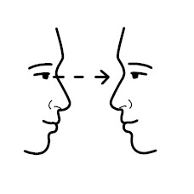

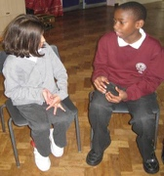 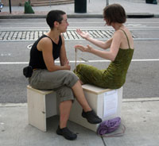

**Norms for Engagement**

* Assume best intentions.
* Listen, fully to a partner, sitting eye to eye and knee to knee (adapt this direction depending on cultural norms).
* If there is silence in the designated time, that is fine. The listener may use nonverbal responses.
* As the listener, do not comment, give feedback or add your story; you are listening not editing giving your fullest attention to the speaker
* Maintain **double confidentiality** – you will not repeat a story heard, and you will not ask your partner about the story s/he tells outside of this exercise unless s/he raises it again with you.

**Facilitator Role**

You will want to model this with a willing person if this is the first time you are using appreciative or constructive listening with this group. Introduce as a way to have someone listen to you completely without judgment for a designated time (usually 2 minutes). Start with dyads (twos/duets).

* + A facilitator reviews directions and keeps time. A timer that beeps is good.
  + Prepare and have participants respond to a designated prompt.
  + State norms of engagement. Ask if there are questions.
  + Let everyone get settled with partner. If they do not know each other (or know each other well), give time for interchange to meet and greet before starting. Have dyad decide who goes first. Be a “warm demander” on the protocols for the dyad, as it is uncomfortable for some at first – but necessary.
  + The first person shares for 2 minutes (or selected time) without interruption, even if he or she is silent. The listener may give nonverbal feedback or subvocalization like “ummm…” but does not include verbal feedback, questions, other stories, etc.
  + Facilitator joins the single person if there is an uneven number.
  + Do clear “bordering” of this activity by setting time and saying “go” and “stop” after two minutes. Make sure the dyads change partners.
  + Debrief activity at end, accepting all responses, but not defending the process. It takes some people longer to get used to this than others.
  + Two minutes for cross-sharing may be added to the end of the protocol.
  + Remind persons of double confidentiality at end of process.

**Adaptations**

* + You may decide to do this in trios after your community has done the dyad work frequently, but do not recommend starting with this.
  + Depending on the content of the sharing, you may decide to ask for persons to contribute their ideas – but not partner’s.
  + You can choose to have full discussion after but remember norms.

1. **The original constructivist listening protocol was designed by Julian Weissglass, Professor Emeritus, UC Santa Barbara. Please transfer this citation to any documents you use for the appreciative/constructivist listening protocol. Weissglass, J. (1990). *Constructivist Listening for Empowerment and Change, The Educational Forum  50*(4), 1990. 351- 370 . The url link to the article is:** [**http://ncee.education.ucsb.edu/articles/constructivistlistening.pdf**](http://ncee.education.ucsb.edu/articles/constructivistlistening.pdf)