**Loving Learning Theory Carnival**

Monday, July 22

7:15-9:15 pm

**PROTOCOL**

**BOOTH ONE**

**Information Processing Machine**

**Role of Metacognition**

|  |  |
| --- | --- |
| **Learning GOAL:**  **Participants can explain information processing and articulate the importance of metacognition to the process.** | |
| **Directions**   1. **Observe the poster of information processing.** 2. **Read your card about component of information processing and decide how you can represent the card in movement and words.** 3. **For example, if the first part of the process is stimuli, then say there are two stimuli: the poster and the card.**   **“I AM A STIMULUS. I want to excite you to learn. I am giving you a card that is going to stimulate your thinking”**   1. **Then arrange yourselves as if you are an IP “machine” and practice/rehearse representing the IP process.** 2. **To debrief, talk about the importance of metacognition and how at every part of the process, thinking about how individuals and groups learn is critical.** 3. **To debrief (if time), talk about the process as itself representative of IP.** 4. **STAMP/GIVE STICKER (?) the CARNIVAL BOOKLET** | |
| **Activities**   1. **The group observes the poster of information processing. Ask: what do you observe about the processing model** 2. **Each person reads an overview of the information processing component.** 3. **The group talks to each other and decides how to represent each of the components in movement and words. Rehearse once and then present** 4. **Group performs the IP “machine”** 5. **Group discusses the importance of metacognition.** | **Materials**   * **Poster of Information Processing** * **Information processing cards for distribution** |

[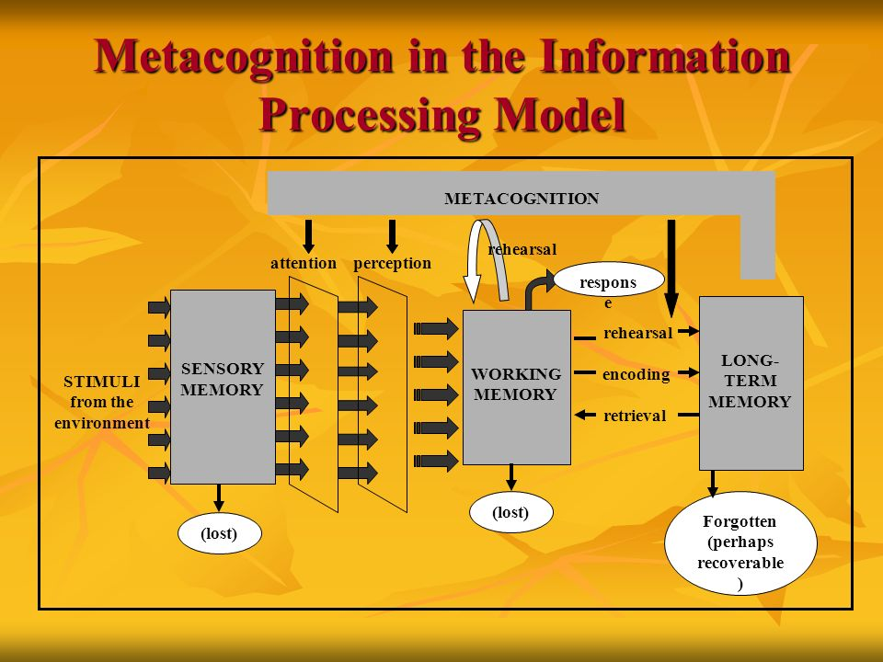](https://www.google.com/url?sa=i&rct=j&q=&esrc=s&source=images&cd=&ved=2ahUKEwjd89yb96fiAhWLdt8KHa1NC0IQjRx6BAgBEAU&url=https://slideplayer.com/slide/8096707/&psig=AOvVaw2xthMfFlTPPeIGdPuZIn2G&ust=1558366891994454)

|  |  |
| --- | --- |
| **STIMULI**  A key variable for IP (information processing). A STIMULUS is a reason or enticement for learning Stimulus must be clear and concise. The stimulus may be a question, a problem, or a process direction. | **REHEARSAL**  In order to “hang onto” the learning, the learner must rehearse the information. It is best to do this orally using language to support the learner’s ability to paraphrase, put the learning into familiar language**.** |
| **SENSORY MEMORY**  The first receptor/receiver of the stimulus. If the stimulus is incomplete, incoherent, or too complicated, the student cannot attend to the stimuli and the input is lost. | **ENCODING**  **Encoding** is the crucial first step to creating a new memory. Piaget calls this assimilation. The learner translates the perceived new information into a construct that can be stored and recalled later from short-term or long-term memory. Mnemonic devices support encoding. |
| **ATTENTION**  The learner must selectively attend to a stimuli that activates the sensory memory. The learner filters the important part of the stimulus in the form of a direction, question, or statement and the brain starts to activate the schema that the learner has in place. | **RETRIEVAL**  The ability to recall information from either working or long-term memory. Retrieval may not happen immediately, and the learner may need cues in order to retrieve and recall. |
| **PERCEPTION**  **Perception is** an unconscious **process. The learner** takes in sensory **information** from the environment and uses that **information** to construct a version of reality. **The main influence on perception is** past experiences. | **LONG TERM MEMORY**  Linking new knowledge explicitly to schema and knowledge already in the brain is vital to what is called synaptic consolidation – consolidating and integrating new information with memory by attending to the complexity of building schema. |
| **WORKING (short term) MEMORY**  The brain stores initial perception and learning for a short time, as the learner becomes aware of the learning through different representations, the learner processes information and starts to attach the new information to the schema already present in the brain. | **METACOGNITION**  **Metacognition** is thinking about one's thinking **processes** such as study skills, best ways to learn, memory capabilities, and the ability to monitor learning. An often-overlooked part of learning, if learners actually attend to how they learned, they are more like to self-regulate and take charge of their learning. |