Learning Theory Carnival
Monday, July 22
7:15-9:15 pm

PROTOCOL
BOOTH Six
Multi-Modal Bruner

Learning GOAL:
Participants can articulate multiple modes of representation according to Bruner’s kinesthetic, iconic (visual) and symbolic (language)
Directions:
- We are here to think about multiple modes of representation as important to learning. Later in the week, we will touch on this again with the Universal Design for Learning. This is more than learning styles; this is supporting students to use different modes or representations to develop a concept…in this case, the importance of circles in our lives.
- Observe circle images. What are your observations
- Watch the video and talk about observations. https://www.youtube.com/watch?v=pNe6fsaCVtI
- Pose the question: What message about circles can you infer from these two images?
- Read the poem aloud and have pairs choose a favorite word, line or phrase. Pose the question: What other messages about circles does the poem convey?
- Then in two groups of 5, the groups should embody the poem and present them.
- If time, discuss how this relates to the three modes of Bruner’s representations.
Activities  - The group observes circle images (video and poster). Talks about observations. What message about circles can you infer from these two images?  - Read the poem aloud and the pairs share favorite phrase or line. What message about circles does the poem convey?  - Then group decides how to embody the poem  - Then discuss how each form (enactive-kinesthetic/iconic and symbolic) enhanced your learning. | Materials  - Poster of Circle Images  - Poem

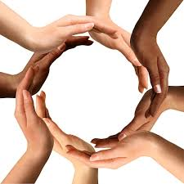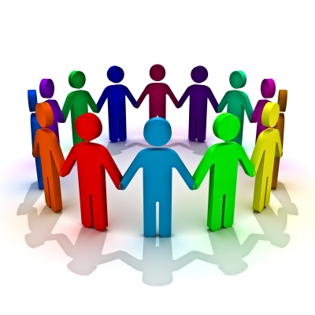

The Circle’s Web

Weren’t we meant
To stand in circles
Feel the round
The curve
The energy inward
The momentum,
Next, across
The smiling eyes
Pick up the dangling word
Finish or help
Hold up, high five
Shoulder the sagging
Join hands
For grace
The glance of glee
The skip of laughter
The push of angst
The wave of mellow
Cradling the spell of memory.

Lynda Tredway, 1996

