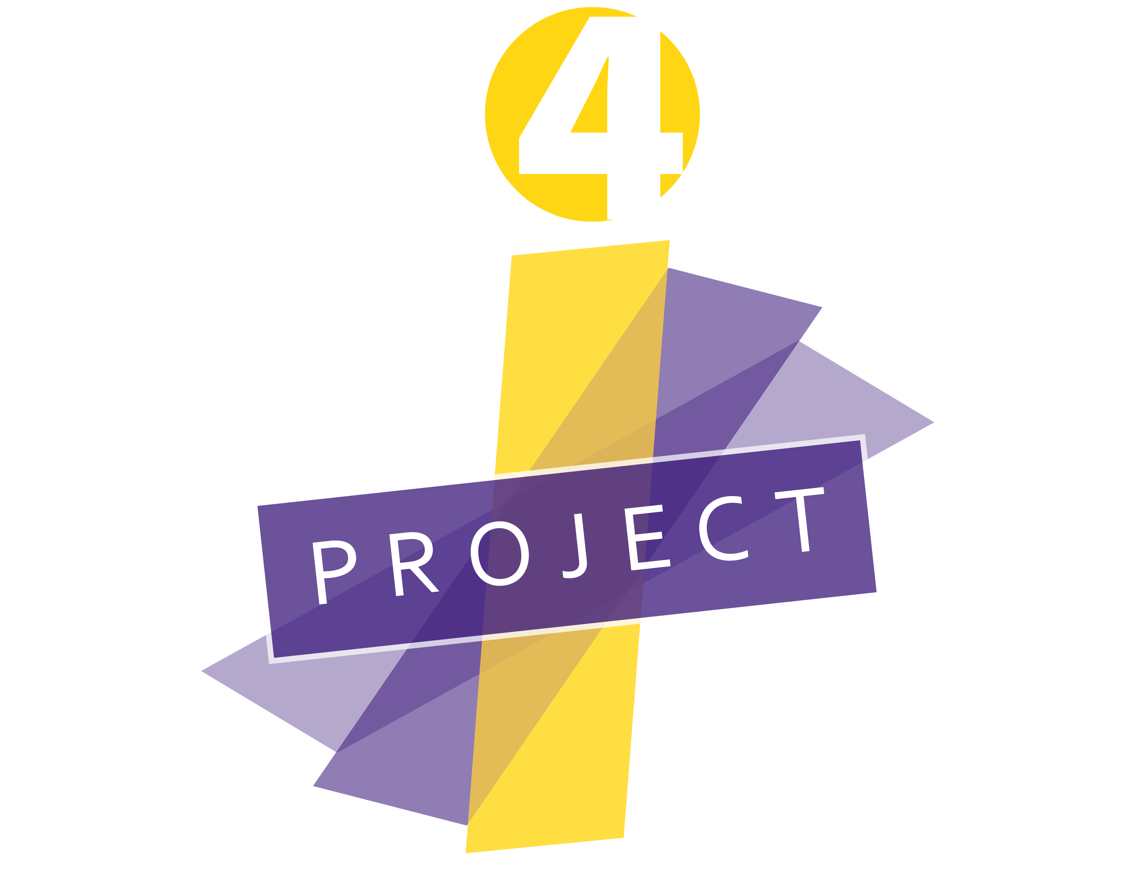

LEARNING EXCHANGE PROTOCOL
ACADEMIC DISCOURSE OBSERVATION TOOLS, Part II
Naming Practice with Selective Verbatim Observation Notes

Step One:
Watch the classroom video and take notes on what you are seeing
Time Stamp | Observations | Notes

Step Two:
Watch the classroom video and use selective verbatim notes. Do NOT try to name any of the practices during the observation and note taking.
Time Stamp | Selective Verbatim Notes | Step 3: Naming Practices

Step Three:
Read the naming definitions below and then add the naming abbreviations to column three above.

5 Cores Skills of Academic Conversation (Zweirs)
Elaborate and Clarify (EC): speaker and listener must be aware of how much detail is needed
Support Ideas with Examples (SI): provide (and ask for) examples to provide evidence to strengthen ideas
Build On | Challenge Ideas (BC): make connections with other ideas to co-construct understanding
Paraphrase (P): identifies what is important and allows for negotiation of meaning
Synthesize Conversation Points (S): organize, prioritize, and shape ideas into summarized form

Questioning Typology
Display Questioning (QD): Answers usually know by teachers. What is the answer to the problem?
Open Questioning
- Personal (QOP): Thoughts, feelings, interpretations. Why did you use this approach?
- Justifying (QOJ): Provide evidence for claim/answer. What evidence do you have?
- Clarifying (QOC): Explain response. What do you mean?
- Elaborating (QOE): Cause and Effect, interpretive thinking. What does that mean multiplying the reciprocal?

Linguistic Traps
Enabling (LTE): Statements that halt conversations. You are on the right track, let’s hear from someone else.

Idioms (LTI): Use of academic and/or cultural specific references or metaphors that may not be understood by all. Dissect the article, On the right track, The gory details, Inside the beltway, Crux of the matter.

Other possible naming of practices
Teacher Moves: Waiting, Inviting, Revoicing, Asking, Probing, Creating

Gestures [non verbal cues]

Connection to Background: Examples, Analogies, Personifying

More on Questioning: Knowledge, Comprehension, Application, Analysis , Synthesis, Evaluation

Practice Videos
http://players.brightcove.net/5387496875001/default_default/index.html?videoId=5530825748001

http://players.brightcove.net/5387496875001/default_default/index.html?videoId=5530850509001

http://players.brightcove.net/5387496875001/default_default/index.html?videoId=5530846490001

http://players.brightcove.net/5387496875001/default_default/index.html?videoId=5530853129001

http://players.brightcove.net/5387496875001/default_default/index.html?videoId=5530833005001

