Favorite Wrong Answer Activity

After completing the Function Vending Machine Sketch, students were asked the following:

Using the terms “input” and “output” write a definition for function based on your exploration of the machines.

Five student answers are shown below. Consider these answers as the student solutions that have been selected to share for a whole class discussion. In your groups:
- Determine which is your “favorite wrong” definition(s) to start the class discussion with. Provide a justification of your choice.
- Describe the order of how you would sequence these student responses as part of a whole class discussion about the definition of function.
- What questions and discourse moves would be useful to help connect these student definitions to come to a class definition for function? Indicate what vending machines you will draw upon as examples during the discussion.

Student Response 1:

Student Response 2: 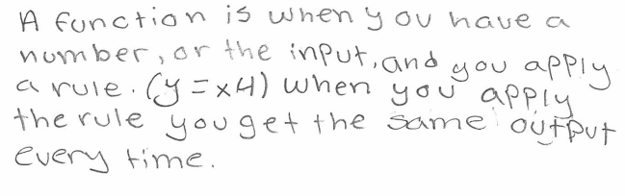

Student Response 3:

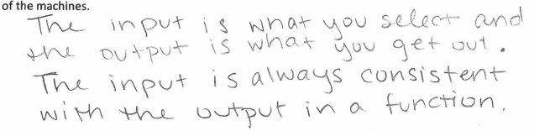

Student Response 4:
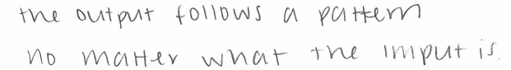

Student Response 5:
